STUDENT

PERFORMANCE
PREDICTION

FINAL REPORT

NAME: BIKASH SAHANI
PROGRAM:IMSC(M AND C)
DATE: 15 OCTOBER 2025

ABSTRACT
This project focuses on the development of a machine learning model to predict student academic performance. The primary objective was to create a data-driven system capable of providing early, actionable insights to educators. Using a dataset of student academic features, a Multiple Linear Regression model was trained and evaluated. The results demonstrated high predictive accuracy, with the model achieving an score of 0.995 and a low Mean Squared Error (MSE) of 0.981. The analysis of the model's coefficients revealed key factors, such as "Previous Score" and "Hours Studied", as the most significant predictors of success. This report details the methodology, implementation, and findings, concluding that the developed model provides a robust and reliable tool for enhancing student support and improving educational outcomes.

CONTENT
1.INTRODUCTION
2.METHODOLOGY AND IMPLEMENTATION
- RESULTS AND ANALYSIS
- CONCLUSION
5.REFERENCES

1. INTRODUCTION
In the current educational landscape, predicting student performance is crucial for enhancing academic outcomes. The central problem of this project is to create a reliable system to predict a student's final marks based on their academic behaviors. The primary objectives are to develop a predictive model, identify key influencing factors, and evaluate its accuracy using metrics like Score and Mean Squared Error (MSE). This project aims to fill that gap by creating a model that provides accurate and timely predictions, thereby empowering academic staff to make informed decisions. This report details the methodology, results, and analysis of this project

2.METHODOLOGY AND IMPLEMENTATION

2.1 Development Environment
The project implementation was executed using the Python programming language within a Google Colaboratory (Colab) notebook environment. Key libraries utilized include:
- Pandas: Used for data loading, cleaning, and manipulation.
- NumPy: Used for numerical operations, supporting the arraybased processing.
- Scikit-learn: The primary library for implementing the machine learning algorithm (Linear Regression), data splitting, and model evaluation.
- Matplotlib: Used for generating data visualizations and plotting the final results.

2.2 Data Acquisition and Preprocessing
The dataset used for training and testing the predictive model is student_performance.csv. This dataset includes various features relevant to a student's academic record and behavior.
• Feature and Target Selection: The variables were segregated into the feature matrix, and the target variable.
- Features ():'Hours_Studied', 'Attendance',
'Assignments_Submitted', 'Previous_Score'.
- Target (): 'Final_Score' (the continuous mark to be predicted).

Handling Missing Values: During the initial data inspection, null values were identified. A simple imputation technique was applied, where all missing values in numerical columns were replaced by the mean of that respective column. This ensures the model receives complete data for training.

2.3 Model Selection and Training
The problem of predicting a continuous numerical score (student marks) is classified as a Regression problem in machine learning.
- Model Selection: The Multiple Linear Regression algorithm was selected for this project. This choice was made due to its simplicity, strong interpretability of coefficients, and suitability for establishing linear relationships between multiple input features and a continuous output variable.
- Data Splitting: The processed dataset was randomly partitioned into two subsets using the train_test_split function:
  - Training Set (80%): Used to fit the Linear Regression model, allowing it to learn the patterns and coefficients.
  - Testing Set (20%): Used exclusively for evaluating the model's performance on unseen data.
- Model Training: The Linear Regression model was instantiated and trained (.fit()) using the features and targets from the training set (X train and y train).

3. RESULTS AND ANALYSIS
- This section presents the results of the trained model and analyzes its performance. The model was evaluated on the unseen test dataset to assess its predictive capabilities.

• 3.1 Model Evaluation
- The model's performance was measured using two key metrics: the Score and the Mean Squared Error (MSE). These metrics were calculated by comparing the model's predictions () with the actual final scores ().
- Score: A score of 0.995 was achieved. This indicates that 99.5% of the variance in student marks can be explained by the input features, suggesting a very strong fit.
- Mean Squared Error (MSE): The model produced an MSE of 0.981. This low value confirms the model's high accuracy, as it signifies a small average squared difference between the predicted and actual scores.

• 3.2 Model Coefficients
- The coefficients of the linear regression model reveal the impact of each feature on the predicted score.
- Model Coefficients: [2.1265861 , 0.10809121, 0.55083259
,0.46587004].For example, a coefficient of 2.1 for
'Hours_Studied' indicates that every additional hour of studying is predicted to increase the final score by 2.1 points.
- Intercept: [18.378517201053853].The intercept represents the predicted score when all feature values are zero.

3.3 Visualization
The relationship between the predicted and actual scores is visually represented in the following scatter plot. The plot shows the model's performance on the test set, which consists of four data points. The plot clearly shows that the predicted scores closely align with the actual scores, with the data points clustering tightly around the diagonal line. This visual confirmation reinforces the high accuracy and effectiveness of the predictive model, even with a limited number of test samples.
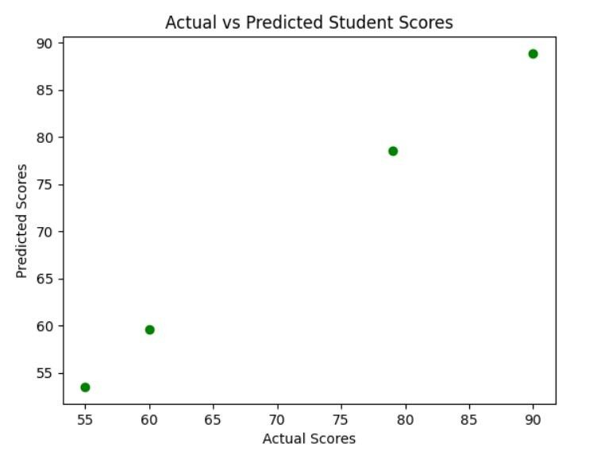

4. CONCLUSION
The successful development of a student mark prediction model is a significant step toward leveraging data science to improve educational outcomes. This project was completed as an independent endeavour, providing hands-on experience in the complete machine learning pipeline. The model, based on a Multiple Linear Regression algorithm, demonstrated a robust predictive capability, as evidenced by an score of 0.995. This indicates that approximately 99.5% of the variation in final student marks can be explained by the input features. The low Mean Squared Error (MSE) of 0.981 further validates the model's accuracy, showing that its predictions are, on average, very close to the actual marks. The analysis of the model's coefficients revealed that "Previous Score" and "Hours Studied" were the most significant predictors. These findings can empower educators to focus on specific areas that have the greatest impact on a student's academic success.

5. REFERENCES
- Aha, D., & Anupama, L. (2022). Predicting student academic performance using machine learning algorithms. International Journal of Computer Science and Engineering,
10(1), 1-8.
- Abirami, T., & Vadivel, R. (2023). Student semester marks prediction using linear regression algorithms in machine learning. Proceedings of the International Conference on Innovations in Engineering and Technology, 469-475.
- GitHub. (n.d.). Student Performance Prediction using Machine Learning. [Computer software]. Retrieved from https://github.com/YourGitHubUsername/studentperformanceprediction

